Back to the Future
A Sketching and EDP Exercise

Back to the Future is a film trilogy beginning in 1985. Technology is a star of the film with Dr. Emmett Brown as a central character exhibiting numerous examples of scientific and engineering application and thinking. The second film in the series involves Doc Brown taking Marty McFly to the year 2015 to evaluate Marty’s future family.

Activity #1
The time travel depicted in the film would not have happened without Doc Brown’s invention of the Flux Capacitor. To ensure that you have a visual motivator to inspire you this year, sketch the Flux Capacitor in your Engineering Notebook and post the sketch on your PoE website.
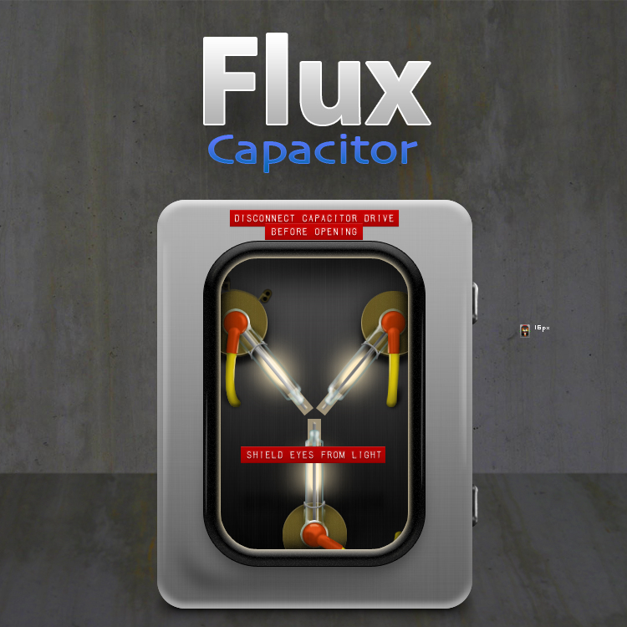
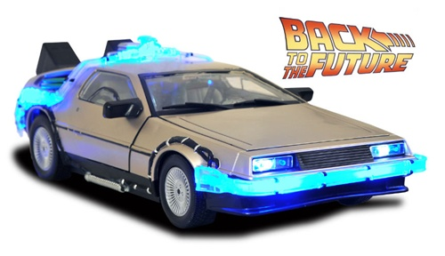
Activity #2
Another unique character occurrence in the film is the conversion of a DeLorean DMC-12 into the time travel vehicle. This was a famous fiberglass chassis and stainless steel brushed body gull wing car available in the early 1980s.

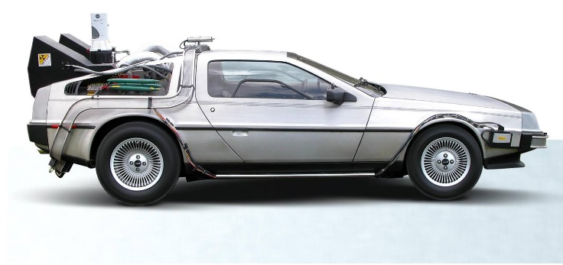
Here are three views of the BTTF DeLorean. Sketch one or more of these in your Engineering Notebook and post the sketch on your PoE website as well.

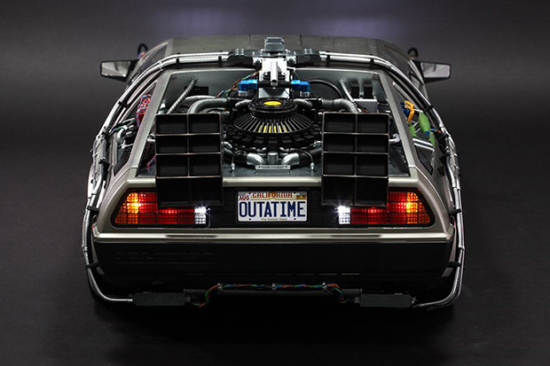

Activity #3
Looking toward the future from 1985, the BTTF film makers painted a visionary picture of 2015. A few items are still under development while some have been realized (big screen home video conferencing, news drones, self-lacing shoes, flying cars). Put yourself in the position of providing the technology predictions for a time travel film where the character transports to 2045. Brainstorm with peers regarding what products would exist, personally select a product, and sketch and describe a prototype. Capture the brainstorm data and prototype development in your Engineering Notebook and post the prototype sketch and description on your PoE website. #BTTF2045

